The History of Processors

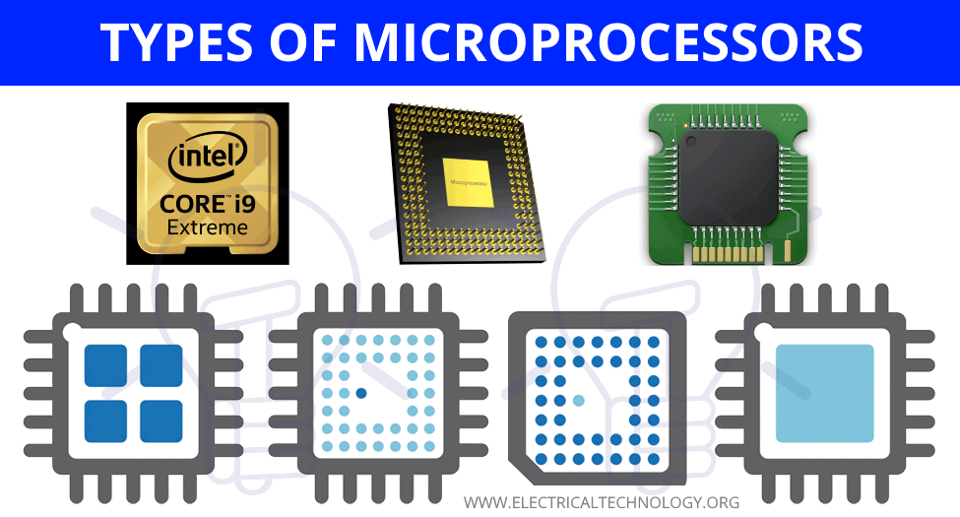 | Microprocessors are the 'brain' of modern computers and electronic devices.

Early Beginnings: Vacuum Tubes and Transistors
- 1940s-1950s: Vacuum Tubes: The first generation of computers used vacuum tubes for circuitry and magnetic drums for memory. Vacuum tubes were large which made the computer too big, also they created too much heat. | 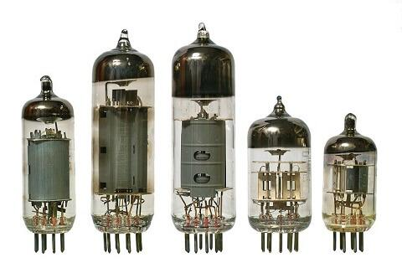
- 1950s: Transistors: We replaced vacuum tubes with transistors. Transistors allowed computers to become smaller, faster, and more much more reliable. | 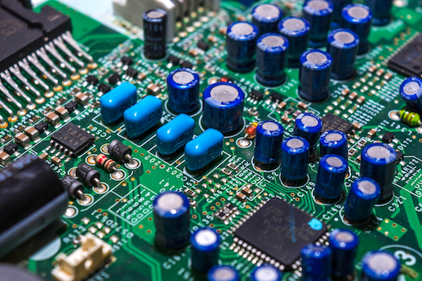
The Advent of Integrated Circuits
- 1960s: Integrated Circuits: Integrated circuits revolutionized computing by placing many transistors on a single silicon chip, leading to the development of the first microprocessors. | 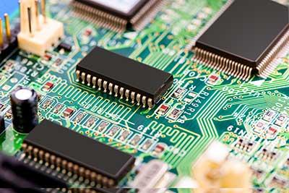
The Evolution of Microprocessors
- 1970s-1980s: Microprocessors allowed for rapid development. This led to increased power, smaller size of computers, and the start of personal computing (e.g., laptops). | 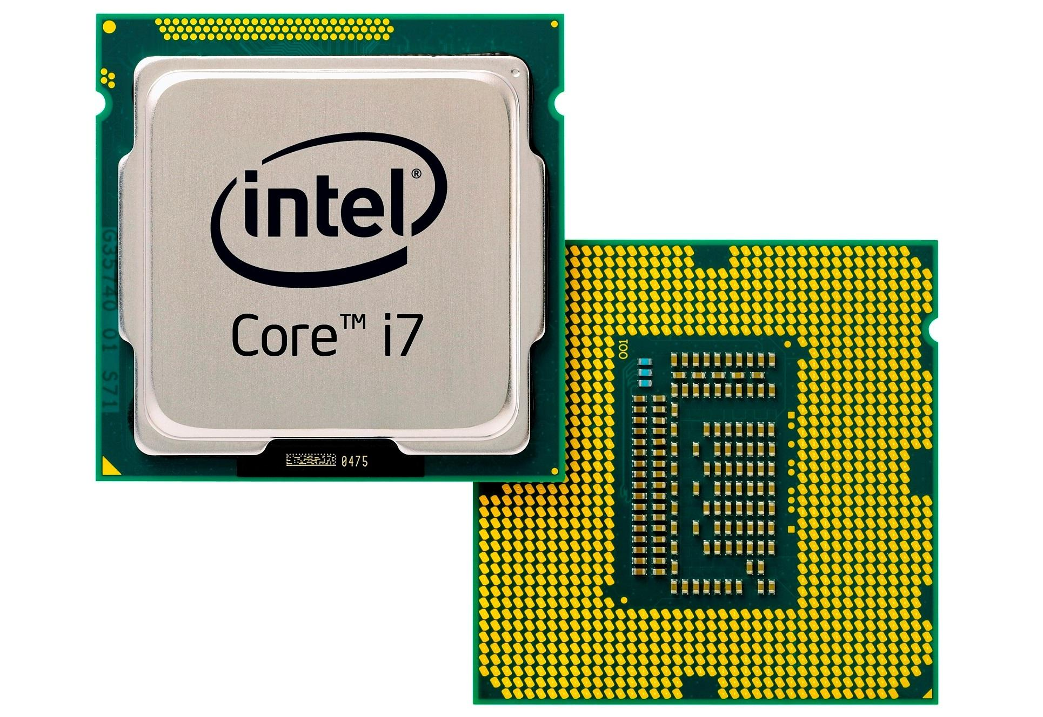
This allowed to development and transition to multi-core processors (e.g., single-core and dual-core processors). This made computers much more efficient processing and multitasking. A single-core processor has one processing unit, meaning it can handle only one set of instructions at a time. A dual-core processor contains two separate cores in the same CPU, allowing it to handle multiple instructions simultaneously. | 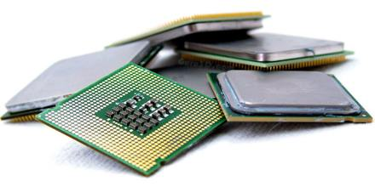
Modern Developments
- 2000s-Present: Advances continued and allow the miniaturization (getting very small) of computers as well as the increase in processing power.
- Current Trends: Modern microprocessors are now driving developments in AI, IoT (Internet of Things), and high-performance computing.
Conclusion: The Future of Microprocessors
- Looking Ahead: Future developments, such as quantum computing and potential advancements in nanotechnology and materials science could rocket computers into unknown levels of development. Quantum processors in quantum computing use the rules of quantum physics, which means they can do some calculations really fast, much faster than traditional processors. This makes them super good at solving really tricky problems, like breaking codes or helping scientists discover new medicines.

Comprehension Questions
What was the first processor used for computers in circuitry?
What was the major disadvantages of using vacuum tubes?
How did the introduction of transistors in the 1950s impact computers?
What was the advance in computing technology during the 1960s?
What did integrated circuits allow for in the development of microprocessors?
What was a significant result of the rapid development of microprocessors in the 1970s – 1980s?
How does a single-core processor differ from a dual-core processor?
What has been a trend in microprocessors since the 2000s?
In modern times, what are microprocessors significantly contributing to?
What future development in computer technology could greatly advance computing capabilities?

